Project :KfW Soil Project

- Project Village :-Abrakha

- Farmer’s Name -

- Address :- At - Abrakha,PO- Tonapathar, PS- Suiya, Dist.- Banka, Pin - 813106

- Name of Activity:-Farm Bund

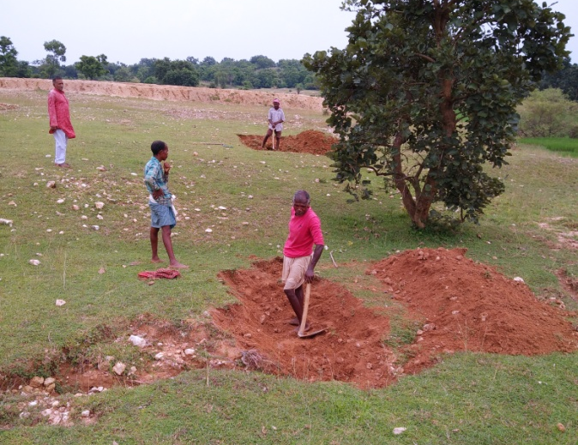
- Month of Initiation:- August 2020

- Problem Statement :-
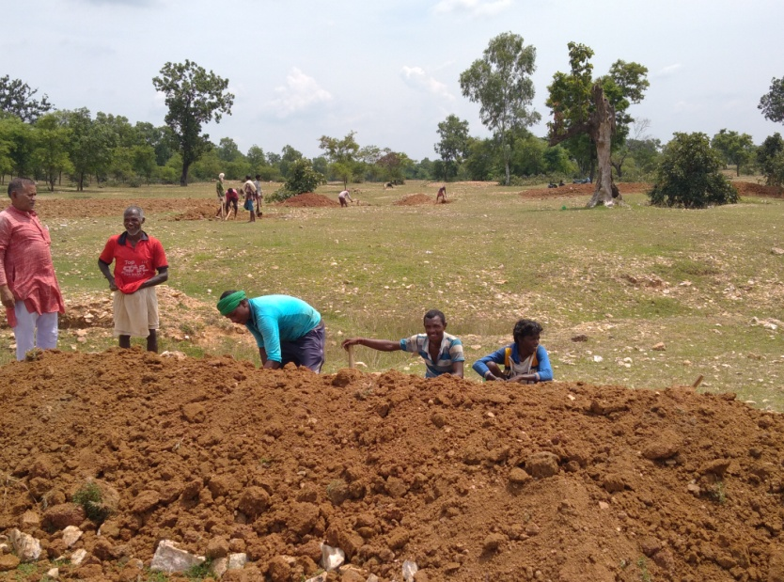
In Abrakha Village there Stood a big dunk of barren land just by the side of the village- habitation. It was a joint property. The land was in the shape of a heap, sloppy, hilly, weedy and stony, some farmers tried to grow some crops but in want of irrigation if failed. People waited to convert the waste land into cultivable land.
- Initiation Taken :-
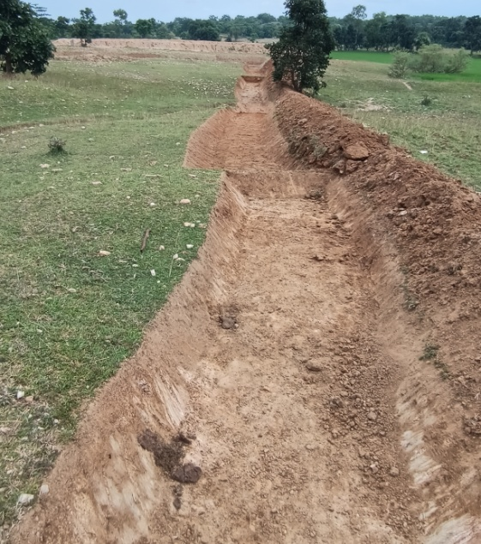
When CCA Project began, this plot was undertaken for farm-bund 996.589 m³. The work begun with 20-30 labours and farmers them selves. Trenches 2’ deep , d inch wide and 250 inch to 400 inch length. In square, uneven shapes in numbers continuously were dug. Grass was planted on bunds and the big plot of land was divided into shaped farm land, best example of rainwater harvesting and collection and coercion of waste-land to cultivable land.

- Progress And Result :-
Farm land is ready. After rain water is available in all field, farmers, have ploughed and made it plane. The have sowed Kurthi and Arhar. They will sow maize, sarso and teel farm the next season.
They will also sow wheat, potato and vegetables if water could be available.

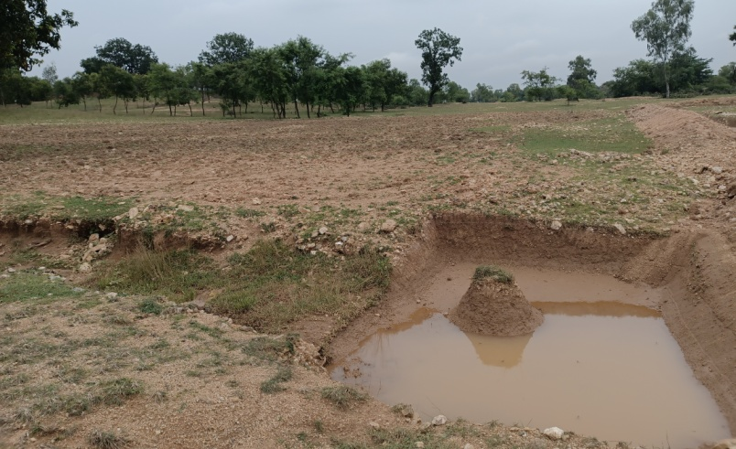
- Impact:-
The village sight is changed with smile and hope on faces. Income has to come now.

- Inspiration :-
United efforts can bring remarkable change.

